# I. Typical Point Cloud Processing pipeline

Single Point Cloud  polygonal mesh  decimation and reparameterization

# 2. Category of Point Cloud

Unstructured point cloud: stored with kd-tree

Stuctured point cloud: stored with regular matrix structure

# 2. Categories for Denoising?

## 2.1 Point Cloud Denoising

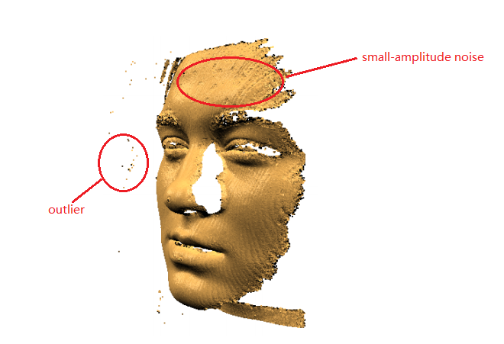

Figure 1 Outlier and Small-amplitude Noise

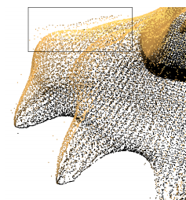

Figure 2 Large Amplitude Noise

## 2.2 Mesh or Surface Denoising

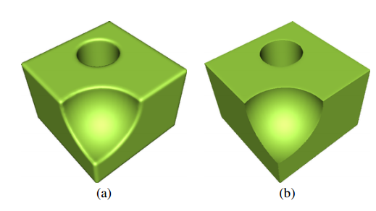

Figure 3 Sharpe Features

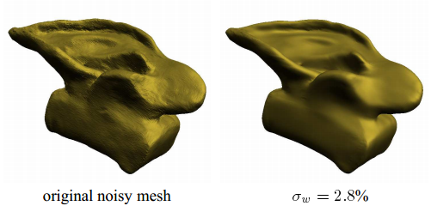

Figure 4 Random Noise

Mesh denoising method by Fleishman

# 4. Categories for Point Cloud Denoising Algorithm?

## 4.1 Statistical-based Filtering Techniques

Conception:

Techniques utilize the adaptation of statistical conceptions.

### 4.1.1 A Kernel based Clustering Approach

2005 Schall et al. [18] “Robust filtering of noisy scattered point data”

Procedure:

Define likelihood function  Calculate Step Size  Move Points  Continue interator

Keywords:

Likelihood Function

Advantages:

Good at outlier detection

Shortcomings:

Failed with sharp features

### 4.1.2 Method Based on a Weighted Variant of the Principal Component Analysis

2006 Narváez et al. [15] “Point cloud denoising using robust principal component analysis”

Procedure:

Weight factor assignment  estimate a weighted covariance matrix  get fitting plane

### 4.1.3 Method Based on Bayesian Statistics

2006 P.W.M. Jenke at al.[20] “Bayesian point cloud reconstruction”

### 4.1.4 Method Based on a Statistics Framework

2009 E. Kalogerakis et al. [21]“Extracting lines of curvature from noisy point clouds”

### 4.1.5 Method Based on L1-sparity paradigm

2010 H. Avron at al. [22]“L1-sparse reconstruction of sharp point set surfaces”

### 4.1.6 Method Based on Growing Neural Gas Network

2013 S. Orts-Escolano et al.[24] “Point cloud data filtering and downsampling using growing natural gas”

## 4.2 Neighborhood-based Filtering Techniques

This technique determines the filtered position of a point using similarity between a point and its neighborhood.

### 4.2.1 Method Based on Bilateral Filtering (Expand from Image Filtering)

1998 C. Tomasi, R. Manduchi.[30] “Bilateral filtering for gray and color images”

This method required a mesh generation progress. In order to tackle that problem, this paper applied the bilateral filtering based on the point position and intensity.

2015 W. Xu et al.[39] “Multiview-based hand posture recognition method based on point cloud”( little relevance)

### 4.2.2 Method Based on Mean Shift (Expand from Image Filtering)

Hu et al. [44]

### 4.2.3 Method Based on non-local means method (Expand from Image Filtering)

Schall et al. [17]

Huhle et al. [12]

### 4.2.4 Connectivity-based Approach and Clustering-based Approach

Wang et al. [46]

## Projection-based Filtering Approaches

Conception:

This technique adjusts the position of each point in a point cloud via different projection strategy.

### 4.3.1 Method Based on Locally Optimal Projection Operator (LOP)

2007 Y. Lipman et al. [51] “Parameterization-free projection for geometry reconstruction”

LOP

2009 Huang et al. [49] “Consolidation of unorganized point clouds for surface reconstruction”

WLOP, an improvement for LOP

2011 Ye et al. [53] “Accurate 3d pose estimation from a single depth image”

Improvement of WLOP with the parameter h

2013 Liao et al. [54] “Efficient feature-preserving local projection operatorfor geometry reconstruction”

FLOP, an improvement for LOP

2013 Huang et al. [55] “Edge-aware point set resampling”

Proposed an isotropic LOP

2014 Preiner et al. [56] “Continuous projection for fast l1 reconstruction”

CLOP, an improvement for LOP

### 4.3.2 Methods based on MLS

Essentially, MLS is a low-pass filter, it can smooth the sharp features.

Levin [57-59], proposed the MLS method

1998 “The approximation power of moving least-squares”

2004 “Mesh-independent surface interpolation”

2004 “Smoothing Noisy Point Clouds with Delaunay Preprocessing and MLS”

Alexa [19,60], applied the MLS method to denosing

2001 “Point set surfaces”

2003 “Computing and rendering point set surfaces”

2002 Pauly et al. [61] “Efficient simplification of point-sampled surfaces”

Proposed an approach to find an suitable global scale factor

2004 Alexa and Adamson [62] “On normals and projection operators for surfaces defined by point sets”

Proposed a simpler projection procedure to decrease the computation

2004 Amenta and Kil [63] “Defining point-set surfaces”

Proposed an explicit version of MLS

2003 Mederos et al. [64] “Robust smoothing of noisy point clouds”

Combine M-estimator procedure and MLS to preserve salient features

2005 Shachar Fleishman “Robust Moving Least-squares Fitting with Sharpe Features”

Combine the MLS and forward search paradigm

2006 Adamson and Alexa. [66] “Point-sampled cell complexes”

Combine cell complexes and MLS

2007 Guennebaud and Gross. [67] “Algebraic point set surfaces”

Solve for the problem when facing high curve

1996 Fual et al. [68] “Reconstructing surfaces from unstructured 3d points”

Fitted a local quadric patch to a neighborhood of every point

2013 Wang et al. [69] “Feature-preserving surface reconstruction from unoriented noisy point data”

Compute the tangent plane with mean shift clustering and adaptive scale sampling consensus

## 4.4 Signal Processing based Method

This technique utilizes the signal processing technologies to deal with point cloud noise.

2001 Lisen [71] “Point Cloud Representation”

Develop a filtering operator contain three features: locality, non-shrinkage and including geometry aspects.

2002 Pauly et al. [72] “Multiresolution Modeling of Point-Sampled Geometry”

They introduced the discrete approximation of laplacian to tackle the shrinkage problem.

2001 Pauly and Gross [73]” Spectral processing of point-sampled geometry”

Used the spectral processing

2013 Rosman et al. [74] “Patch-collaborative spectral point cloud denoising”

Construct the patch use a set of similar patch.

## 4.5 PDEs-based Filtering Technique

Keywords: Partial Differential Equations

Shortcomings: Time consuming.

2004 Clarenz et al. [75] “Fairing of point based surfaces”

Present a framework via PDEs

2005 Lange and Polthier [77] “Anisotropic smoothing of point sets”

Obtain an anisotropic geometric mean curvature flow method to filter point cloud

2006 Xiao et al. [78] “A dynamic balanced flow for filtering point-sampled geometry”

Proposed an anisotropic curvature flow approach

2014 Lozes et al. [79] “Partial difference operators on weighted graphs for image processing on surfaces and point clouds”

Constructed weighted arbitrary graphs for representing point cloud

## 4.6 Hybrid Filtering Technique

Use one or more filtering techniques to deal with the raw point cloud.

2012 Liu et al. [82] “Iterative consolidation of unorganized point clouds”

Combined WLOP and mean-shift-based operator

2016 Zaman et al. [16] “Density-based denoising of point cloud”

Combined kernel density estimation and mean-shift clustering algorithm

## 4.7 Other Methods

1998 Szeliski and Tonnesen et al. [83] “Surface modeling with oriented particle systems”

Developed oriented particles

Voxel Grid (VG) filtering method

Defined a 3D voxel grid

Quadtree-based filtering method

Create a quadtree as a date structure.

2012 Digne et al. [84] “Similarity based filtering of point clouds”

Introduced a similarity filtering

# 3. How to Evaluate the Point Cloud Denoising Result?

# Methods to detect local maxima

Mean shift technique

# How many directions of improved MLS algorithm have? What are the main ideas of them?

# What’s the difference among WLS, MLS and improved MLS by tang?

# How to add confidence parameter into MLS algorithm?

# What’s the difference between surface denoising and smoothing?

Basic surface smoothing method:

1. Methods based on the moving-least-square approach
2. Methods based on diffusion processes
3. Methods based on signal processing
4. Methods based on Local patch similarity
5. Methods expanded from image processing